**Capstone Project: Find the best place to open a gym in Bogotá, Colombia**

To carry out this exercise, it is necessary to identify the postal codes of the different neoghborhood in the city, as well as their geographical location expressed in latitude and longitude.

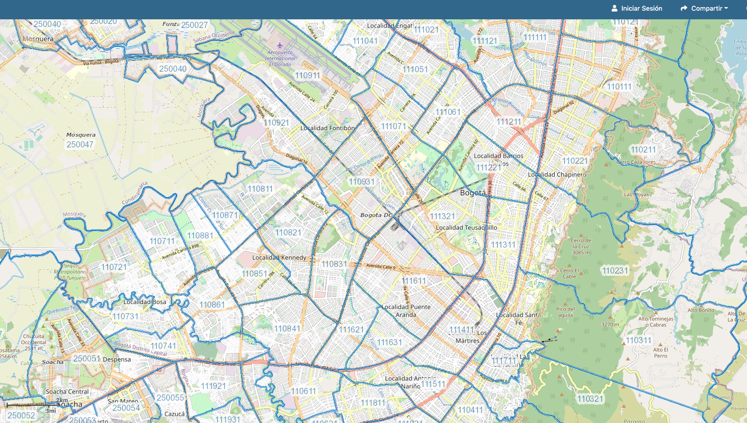

With this information, foursquare data will be used to identify the premises by area and build the grouping model.